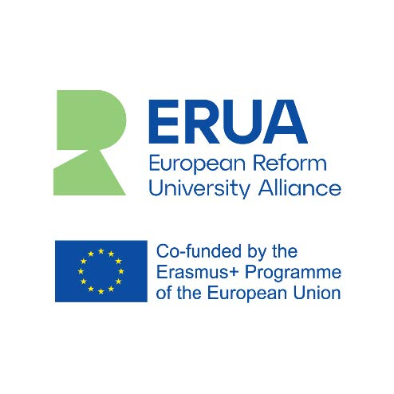
Call for proposals
Innovative joint initiatives in teaching and learning

The ERUA (European Reform University Alliance) is launching a running call for innovative joint initiatives in teaching and learning. The call is open from the date of publication and until further notice.

Aims of the call
This call aims to promote joint innovative teaching initiatives between students and teaching staff at two (or more) ERUA universities. “Innovation” can refer to different aspects, outlined below (cf. selection criteria). “Joint” means collaboration between at least two ERUA member universities.

Funding
The call provides financial support to academic staff interested in developing a joint teaching and learning initiative and is open to all. In collaboration with the applicant’s affiliated university, ERUA supports each proposal with up to one month’s compensation for time spent on developing innovative ideas. Furthermore, the ERUA initiative contributes funding towards travel expenses related to the initiative for staff and students. In addition, we offer help finding potential collaborating ERUA partners (see links, contact info and catalogs below).

Introduction
ERUA brings together five pioneer European universities: the universities of Konstanz (Germany), Roskilde (Denmark), Paris 8 (France), the Aegean (Greece) and the New Bulgarian University (Sofia, Bulgaria). Our consortium, co-funded by the European Commission under the second Erasmus+ ‘European Universities’ call for proposals, was launched on November 1, 2020.

Our mission is to address real-world challenges by bringing together students and academics from diverse areas of Europe and from all socio-economic backgrounds to contribute to reshaping a more just, open and inclusive society.
ERUA promotes innovative experimental approaches that help reimagine the role of higher education. This call for innovative joint initiatives in teaching and learning has the ambition to be an important contribution to this aim.

For more information about ERUA: https://erua-eui.eu/

What do we mean by innovative joint initiatives in teaching and learning’?
ERUA’s innovative joint initiatives in teaching and learning are formats that promote joint initiatives between teaching staff and/or students of two or more of our five Universities. The proposed initiative seeks to reflect and strengthen our profile as reform universities. Therefore, innovation in teaching and learning can refer to different aspects - depending on the context. We aim to develop new teaching and learning formats and give grant holders the opportunity to develop their teaching skills and teaching formats by applying novel concepts or exploring new approaches. ERUA also focuses on academic developments, which support knowledge transfer between students and staff in ERUA, as well as knowledge transfer from university to society and collaboration with external actors regarding current societal challenges. Furthermore, we aim to strengthen higher education development, which supports the empowerment of citizens, critical thinking, political agency and engagement and the co-creation of knowledge across borders, contexts, disciplines, and people. In sum, we hope to promote and inspire a broader idea of what good higher education teaching might look like and be measured on.

Objectives & priorities
The ERUA call for “Innovative joint initiatives in teaching and learning” is a running call, which means you can apply year-round. However, the projects run over a three-year period, from 2021-2023. Initiatives will be selected, based on criteria of collaboration (between two or more of the ERUA universities), long-term sustainability, knowledge sharing, inclusion, and strengthening of students’ multilingual competences, and our reform university objectives.
The idea of the initiative is to connect the universities of the alliance and to encourage innovative forms of teaching, learning, mobility and collaboration between ERUA staff and students.

Eligibility criteria
The call is open to academics from all five universities to design one or more innovative joint initiatives in teaching and learning, which flag the ambitions, ideals, and pedagogical profile of our reform university profile. The initiative can be new or build on already existing innovative courses or initiatives.
The initiatives must include a description of the main objectives, partners, and plan of execution (time, place, format, etc., see below). The initiatives can cover any topic with a clear connection to reform university objectives, innovative pedagogy, as well as current global challenges.

For more information about the application and funding process, contact:

RUC: Shirley Pollak (pollak@ruc.dk)
Paris8: Valeria Manzione (valeria.manzione02@univ-paris8.fr)
NBU: Metodi Metodiev (mmetodiev@nbu.bg)
Konstanz: Ramona Baumgartner (ramona.baumgartner@uni-konstanz.de)
AEGEAN: Katerina Tousko (ktousko@agean.gr)

For information about potential collaborative partners: “Uncovering the possibilities – who are we catalogue”

For inspiration on innovative teaching formats: “Learning in the field – inspiration catalogue”

Applicants should try to describe the following:
Disciplines: | All fields of study
Expected duration of the course:
Formats used: | On-site, online, or blended?
Number of students per university:
Languages: | The courses could be in any language and preferably, students’ multilingual repertoires should be included and strengthened.
Period of the year: | E.g.: 1 November 2021 – 31 October 2022
Entry education level (EQF): | Open to Bachelor, Master and PhD students
Prerequisites:
Student accommodation: | If there is a need of and possibility for providing accommodation to the students, it should be described in the description of the project.
Validation of ECTS: | Automatic recognition of ECTS credits obtained by home university, where possible.

